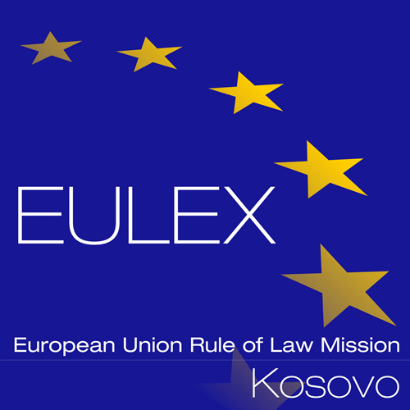

European Union Rule of Law Mission in Kosovo
EULEX Kosovo
Ndertesa Farmed
“Muharrem Fejza” p.n.
Lagja e Spitalit
10000 Pristina, Kosovo
www.eulex-kosovo.eu

CORRIGENDUM No. 2 to the Tender Dossier

PUBLICATION REFERENCE: PROC/444/13/Ammunition and Job Specific Items (EuropeAid/135132/M/SUP/XK)

- The following alterations and/or corrections are made to the Tender Dossier – PART B. Annex II + III: Technical Specifications + Technical Offer

LOT 1: Firearms parts, tools and accessories Table Column 2 – Specifications Required of Item no. 47

Previous Text:
Armorer’s hammers set
Qty:1
Set of three hammers – 100, 200 and 300 grams weight.

Shall now read:
Armorer’s hammers set
Qty:1
Set of three hammers – 100, 200 and 300 grams weight.
Material: Hard metal head – steel
Length of the handle: wooden, between 25 -35 centimeters.

Other terms and conditions of the Tender Dossier remain unchanged. The above alterations and /or corrections to the Tender Notice are integral part of the Tender Dossier.

